**C:\Users\admin\Desktop\download.png**

ERP_Stock Accounting_FRS v1.0

|  |  |  |  |  |  |  |
| --- | --- | --- | --- | --- | --- | --- |
| **Document Name** | **Version Number** | **Start Date** | **Prepared By** | **Reviewed By** | **Modified Date** | **Present Status** |
| Stock Accounting  FRS | 1.0 | 28/04/16 | Santhosh Kumar | Suresh Babu | 2/05/16 | Completed |

1. **Stock Accounting Login :**

**1.1 Overview:**

**Stock Accounting** is a web-based application which will manage stock inventory so easily: Dashboard, Stock Management, Purchasing, Sales, Suppliers, Customers, Outstandings, and Payments. Nice look and feel interface. It supports to be displayed in mobile-device is also in future.

**1.1.1 Prototype**

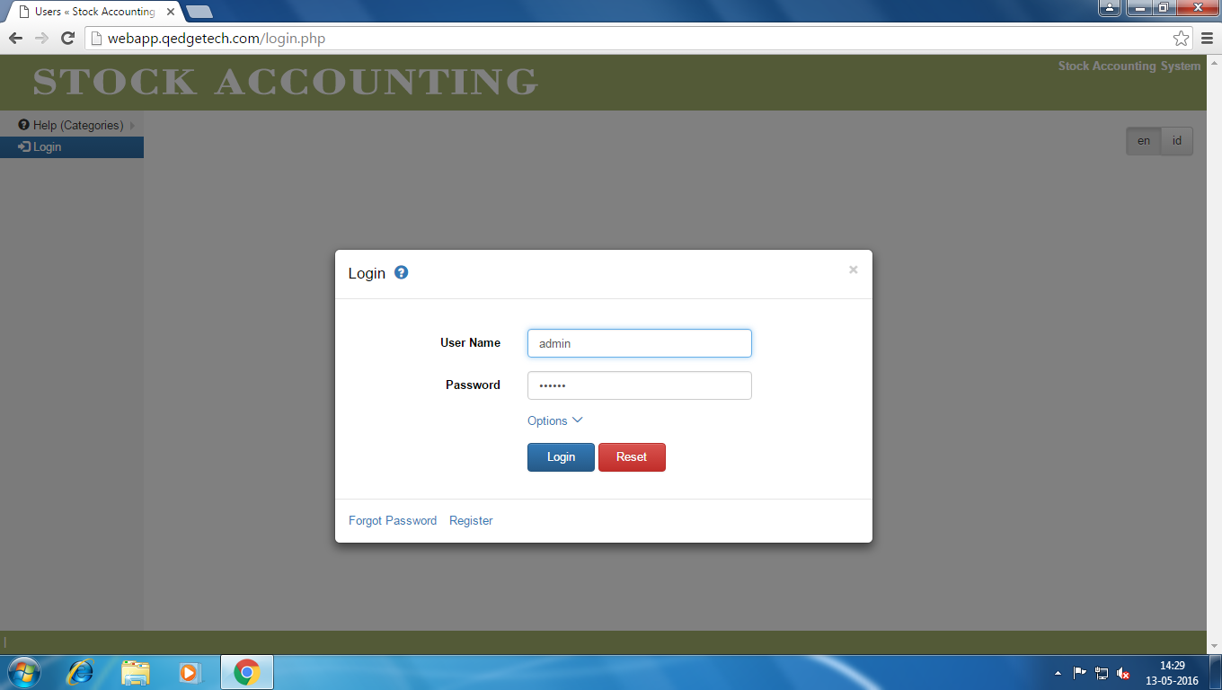

#### 1.1.2 Page Elements

Login Page

|  |  |  |  |
| --- | --- | --- | --- |
| Element Name | Element Type | User Action | System  Response |
| **Admin Login** | |  |  |
| User Name | Textbox | Enter | As per task flow diagram |
| Password | Textbox | Enter | As per task flow diagram |
| Login | Button | Click | As per task flow diagram |
| Reset | Button | Click | As per task flow diagram |
| Options | Link | Click | As per task flow diagram |
| Forgot Password | Link | Click | As per task flow diagram |
| Register | Link | Click | As per task flow diagram |

**1.1.3 Admin UseCase Diagram :**

Enter Valid UserName And Password

Click On Login

System displays Login Details page

System displays Home page of Stock Accounting System

Enter valid URL

**2.0 Stock Accounting Home Page :**

**2.1 OverView:**

This page allows administrator to define and manage master data such as Stock,Suppliers ,Purchases,Customers,Sales and payments related to Stock Accounting.

**2.1.1 Prototype**

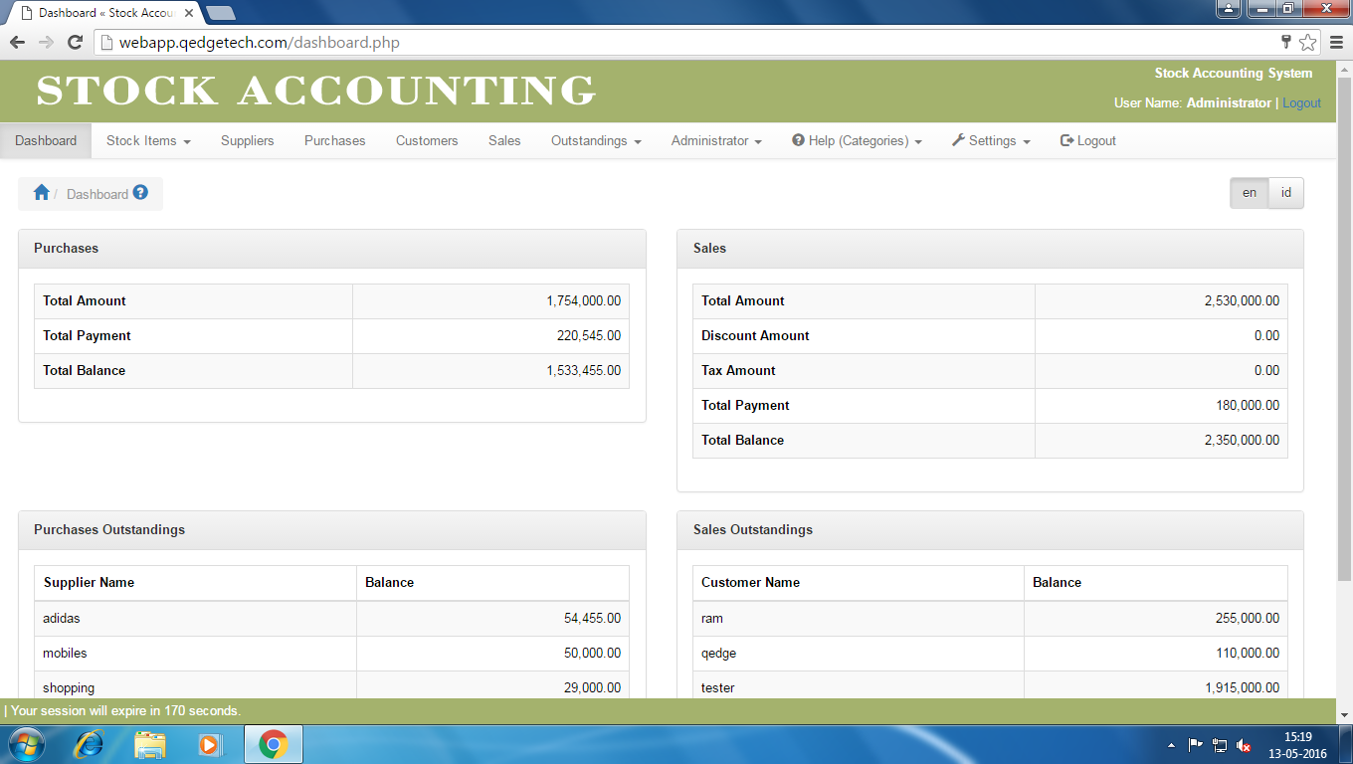

**2.1.2 Page Elements:**

Home Page

|  |  |  |  |
| --- | --- | --- | --- |
| Element Name | Element Type | User Action | System  Response |
| **Home Page** | |  |  |
| Dashboard | Link | Click | As per task flow diagram |
| Stock Items | Link | Enter | As per task flow diagram |
| Suppliers | Link | Click | As per task flow diagram |
| Purchases | Link | Click | As per task flow diagram |
| Customers | Link | Click | As per task flow diagram |
| Sales | Link | Click | As per task flow diagram |
| Outstandings | Link | Click | As per task flow diagram |
| Administrator | Link | Click | As per task flow diagram |
| Help | Link | Click | As per task flow diagram |
| Settings | Link | Click | As per task flow diagram |
| Logout | Link | Click | As per task flow diagram |
| Home | Button | Click | As per task flow diagram |
| Languages | | | |
| En | Label | Click | As per task flow diagram |
| Id | Label | Click | As per task flow diagram |
|  |  |  |  |

**2.1.3 Home Page UseCase Diagram :**

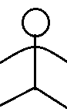

Enter Valid URL

System displays Login Details page

Enter Valid UserName And Password Click On Login

System displays Home page of Stock Accounting System

DashBord

System displays DashBord of Stock Accounting System

Stock Items

System displays information about Stock Items

Suppliers

System displays information about Suppliers Page

Purchases

System displays information about Purchases Page

Customers

System displays information about Customers Page

Sales

System displays Sales Page

System displays Out Standings Page

Administrator

System displays Administrator Page

System displays Help (Categories) Page

LogOut

System LogOut

OutStandings

Help(Categories)

System displays Settings Page

Settings

1. **Stock Items:**

**3.1 Overview:**

Stock Items Feature allows admin to define a new stock, modify or delete any stock items and also admin can search for stock information based on the given selection criteria.

**3.1.1 Prototype**

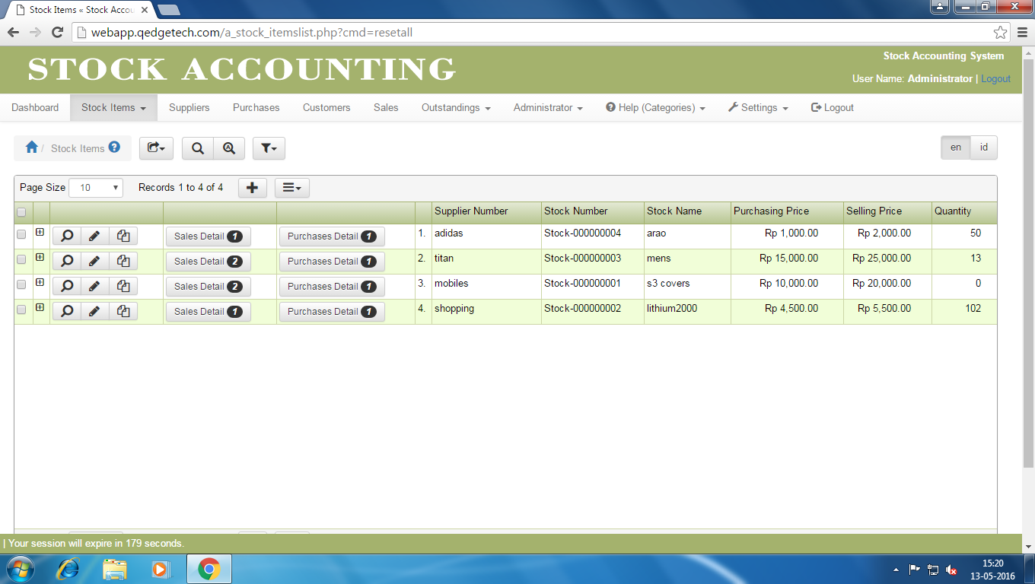

**3.1.2 Page Elements :**

Stock Items Page

|  |  |  |  |
| --- | --- | --- | --- |
| Element Name | Element Type | User Action | System  Response |
| **Stock Items** | |  |  |
| Export | Button | Click | As per task flow diagram |
| Search | Button | Click | As per task flow diagram |
| Advance Search | Link | Click | As per task flow diagram |
| Filter | Link | Click | As per task flow diagram |
| Stock Items Table | | | |
| Check Box | Button | Click | As per task flow diagram |
| Span | Button | Click | As per task flow diagram |
| View | Button | Click | As per task flow diagram |
| Edit | Button | Click | As per task flow diagram |
| Copy | Button | Click | As per task flow diagram |
| Sales Details | Link | Click | As per task flow diagram |
| Purchase Details | Link | Click | As per task flow diagram |
| Page Size | List Box | Slect | As per task flow diagram |
| Add | Button | Click | As per task flow diagram |
| Actions | Button | Click | As per task flow diagram |

**3.2.0 Stock Categorie :**

**3.2.1 Overview:**

Stock Categories Feature allows admin to define a new Stock Categorie, modify or delete any stock Categories and also admin can search for Stock categorie information based on the given selection criteria.

**3.2.2 Prototype**

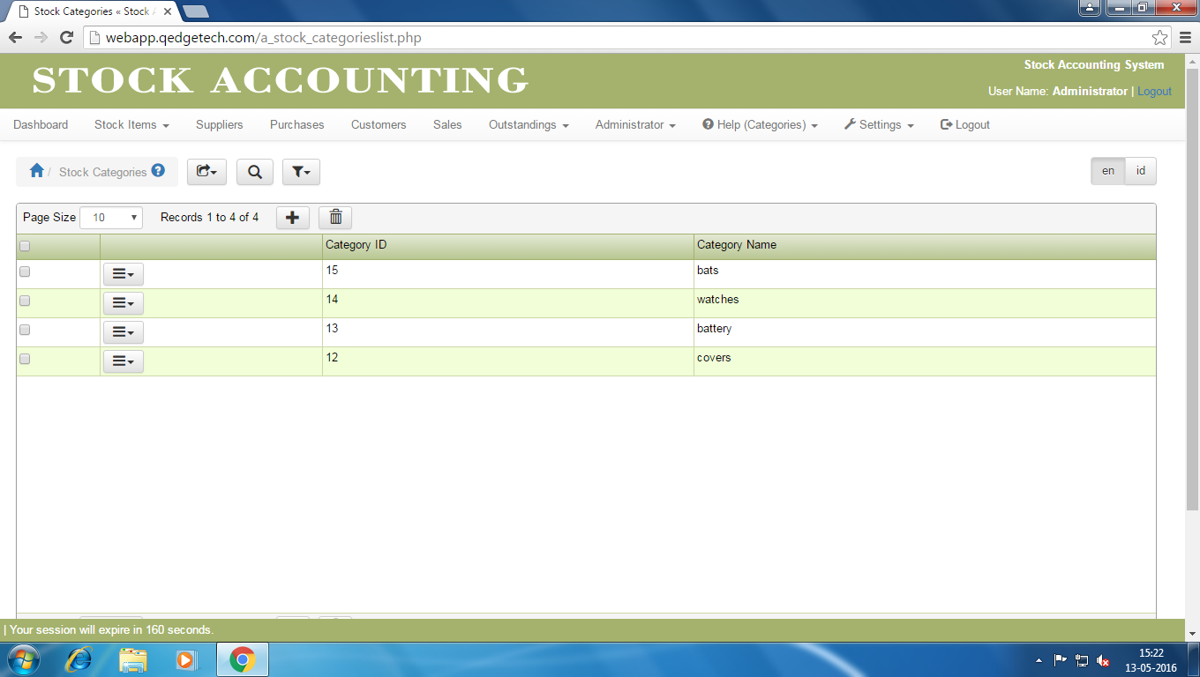

3.2.3 Page Elements :

Stock Categories Page

|  |  |  |  |
| --- | --- | --- | --- |
| Element Name | Element Type | User Action | System  Response |
| **Stock Categories** | |  |  |
| Export | Button | Click | As per task flow diagram |
| Search | Button | Click | As per task flow diagram |
| Advance Search | Link | Click | As per task flow diagram |
| Filters | Link | Click | As per task flow diagram |
| Stock Categories Table | | | |
| Check Box | Check Box | Click | As per task flow diagram |
| Page Size | List Box | Select | As per task flow diagram |
| Add | Button | Click | As per task flow diagram |
| Delete | Button | Click | As per task flow diagram |
| Options | Button | Click | As per task flow diagram |
|  | | | |
|  |  |  |  |
|  |  |  |  |

**3.3.0 Stock Item creation:**

**3.3.1 Overview:**

This feature allows Admin to create a new Stock Item for Stock Accounting.

**3.3.2 Prototype**

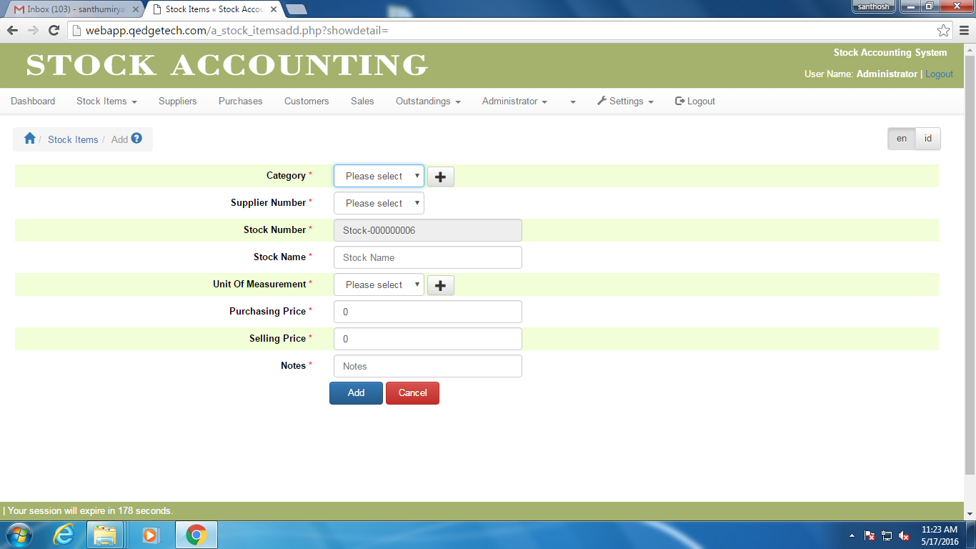

**3.3.3 Stock Item creation UseCase Diagram:**

If valid

Click Add

Enter Stock Item Details

Click Add

Click Cancel

**3.4.0 Stock Item Updation :**

**3.4.1 Overview:**

This feature allows Admin to modify the details of a Stock Items.

**3.4.2 Prototype**

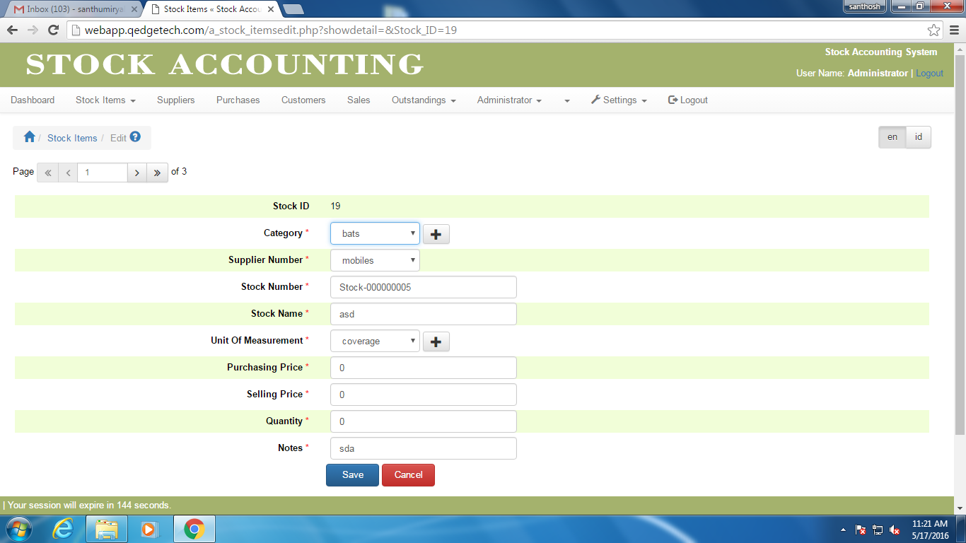

**3.4.3 Stock Item Updation :**

If valid

Click Edit

Enter Stock Item Details

Click Save

Click Cancel

**3.5.0 Stock Item copy :**

**3.5.1 Overview:**

This feature allows Admin to copy the details of a Stock Items.

**3.5.2 Prototype**

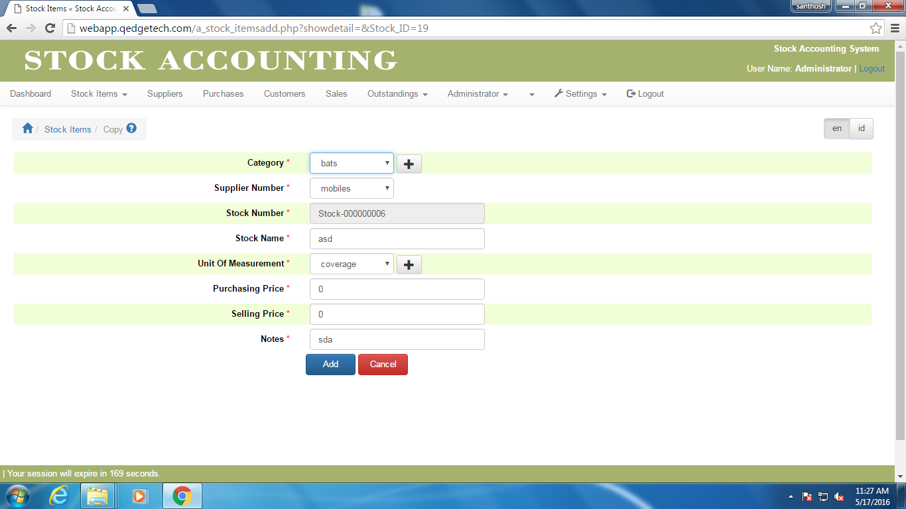

**3.5.3 Stock Item copy :**

No

yes

If valid

Click Copy

Enter Stock Item Details

Click Add

Click Cancel

**3.6.0 Stock Item Deletion :**

3.6.1 Overview:

This feature is useful for Admin to delete an unwanted Stock Items

If Dependency

Select Record

Click Action & Click Delete

Click Ok

Click Cancel

yes

No

**4.0 Suppliers Details :**

**4.1 Overview:**

Suppliers Feature allows admin to define a new supplier, modify or delete and any supplier also admin can search for suppliers information based on the given selection criteria.

**4.1.2 Prototype**

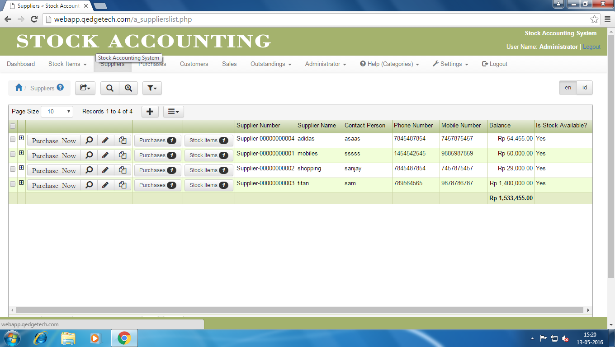

**4.1.3 Page Elements:**

Suppliers Page

|  |  |  |  |
| --- | --- | --- | --- |
| Element Name | Element Type | User Action | System  Response |
| **Suppliers** | |  |  |
| Export | Button | Click | As per task flow diagram |
| Search | Button | Click | As per task flow diagram |
| Advance Search | Link | Click | As per task flow diagram |
| Filter | Link | Click | As per task flow diagram |
| Suppliers Table | | | |
| Check Box | Button | Click | As per task flow diagram |
| Span | Button | Click | As per task flow diagram |
| View | Button | Click | As per task flow diagram |
| Purchase Now | Link | Click | As per task flow diagram |
| Edit | Button | Click | As per task flow diagram |
| Copy | Button | Click | As per task flow diagram |
| Purchases | Link | Click | As per task flow diagram |
| Stock Items | Link | Click | As per task flow diagram |
| Page Size | List Box | Select | As per task flow diagram |
| Add | Button | Click | As per task flow diagram |
| Actions | Button | Click | As per task flow diagram |

**4.2.0 Suppliers Creation:**

**4.2.1 Overview:**

This feature allows Admin to create a new Supplier for Stock Accounting.

**4.2.2 Prototype**

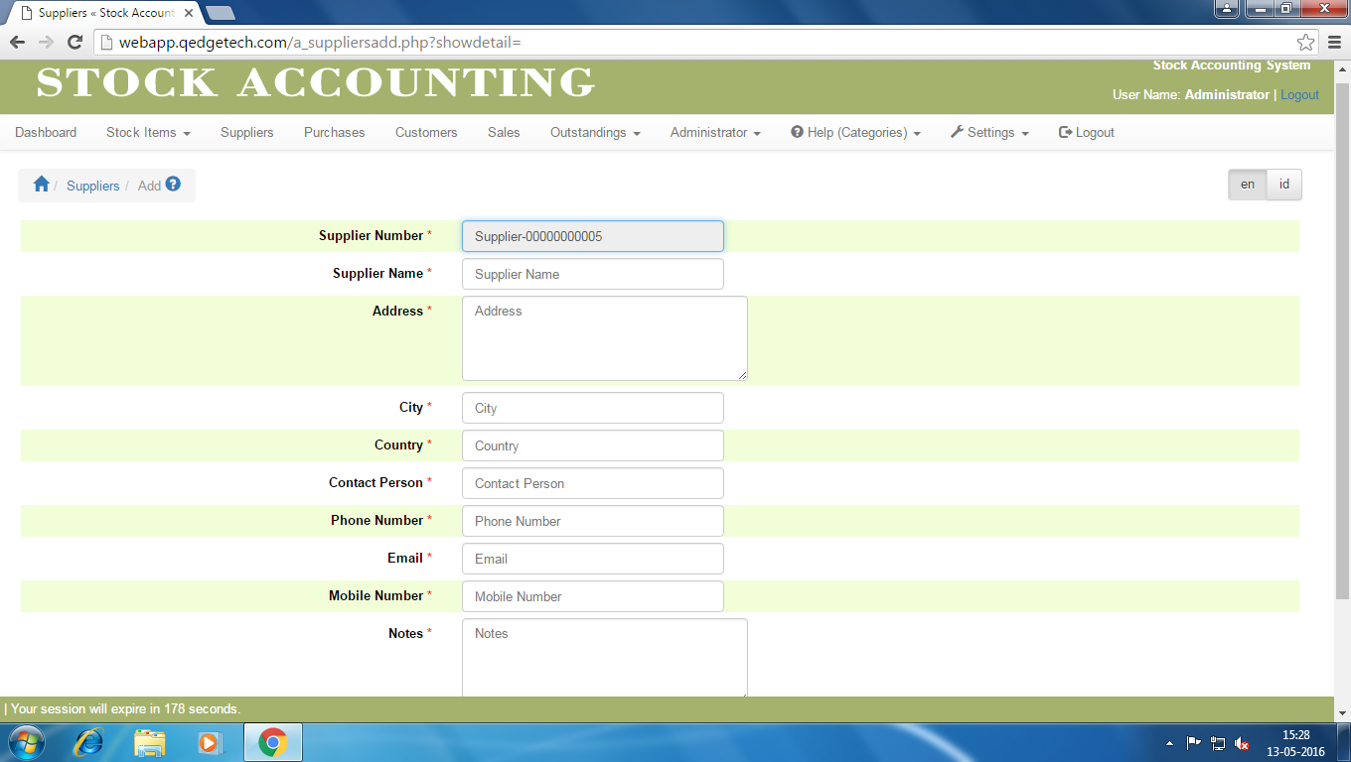

**4.2.3 Page Elements :**

Supplier Creation Page

|  |  |  |  |
| --- | --- | --- | --- |
| Element Name | Element Type | User Action | System  Response |
| **Supplier Creation** | |  |  |
| Supplier Number | Text Box | Auto fill | As per task flow diagram |
| Supplier Name | Text Box | Enter | As per task flow diagram |
| Address | Text Box | Enter | As per task flow diagram |
| City | Text Box | Enter | As per task flow diagram |
| Country | Text Box | Enter | As per task flow diagram |
| Contact Person | Text Box | Enter | As per task flow diagram |
| Phone Number | Text Box | Enter | As per task flow diagram |
| Email | Text Box | Enter | As per task flow diagram |
| Mobile Number | Text Box | Enter | As per task flow diagram |
| Notes | Text Box | Enter | As per task flow diagram |
| Add | Button | Click | As per task flow diagram |
| Cancel | Button | Click | As per task flow diagram |

**4.2.4 Suppliers Creation UseCase Diagram :**

If valid

Click Add

Enter Supplier Details

Click Add

Click Cancel

**4.3.0 Suppliers updation:**

**4.3.1 Overview:**

This feature allows Admin to modify the details of suppliers.

**4.3.2 Prototype**

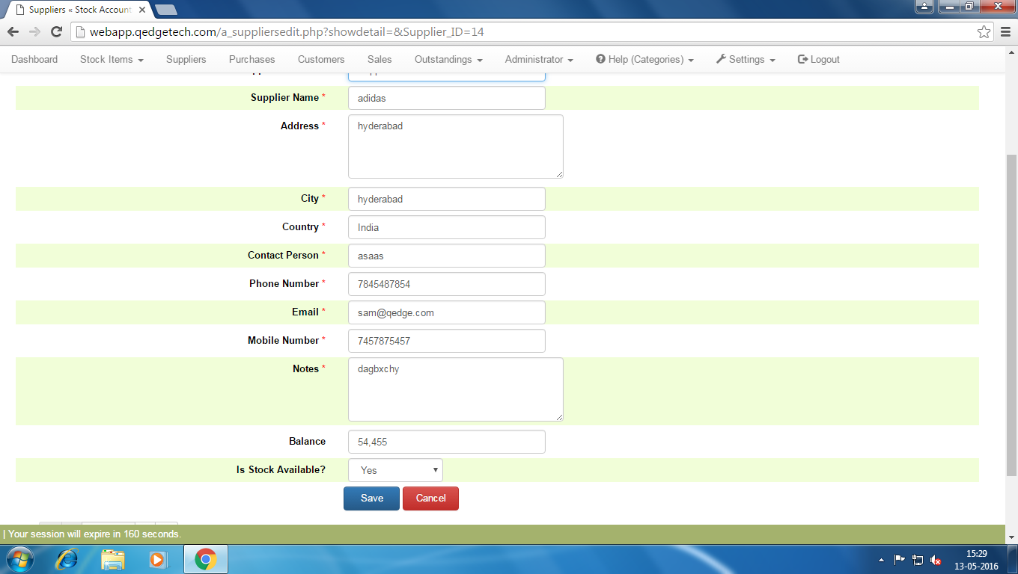

**4.3.3 Page Elements :**

Supplier Updation Page

|  |  |  |  |
| --- | --- | --- | --- |
| Element Name | Element Type | User Action | System  Response |
| **Supplier Updation** | |  |  |
| Supplier Number | Text Box | Auto fill | As per task flow diagram |
| Supplier Name | Text Box | Enter | As per task flow diagram |
| Address | Text Box | Enter | As per task flow diagram |
| City | Text Box | Enter | As per task flow diagram |
| Country | Text Box | Enter | As per task flow diagram |
| Contact Person | Text Box | Enter | As per task flow diagram |
| Phone Number | Text Box | Enter | As per task flow diagram |
| Email | Text Box | Enter | As per task flow diagram |
| Mobile Number | Text Box | Enter | As per task flow diagram |
| Notes | Text Box | Enter | As per task flow diagram |
| Balance | Text Box | Enter | As per task flow diagram |
| Is Stock available | List Box | Select | As per task flow diagram |
| Save | Button | Click | As per task flow diagram |
| Cancel | Button | Click | As per task flow diagram |
| Page | Text Box | Enter | As per task flow diagram |

**4.3.4 Suppliers updation UseCase Diagram :**

If valid

Click Edit

Enter Supplier Details

Click Save

Click Cancel

**4.4 Suppliers Copy:**

**4.4.1 Overview**

This feature allows Admin to copy the details of a Supplier.

**4.4.2 Prototype**  
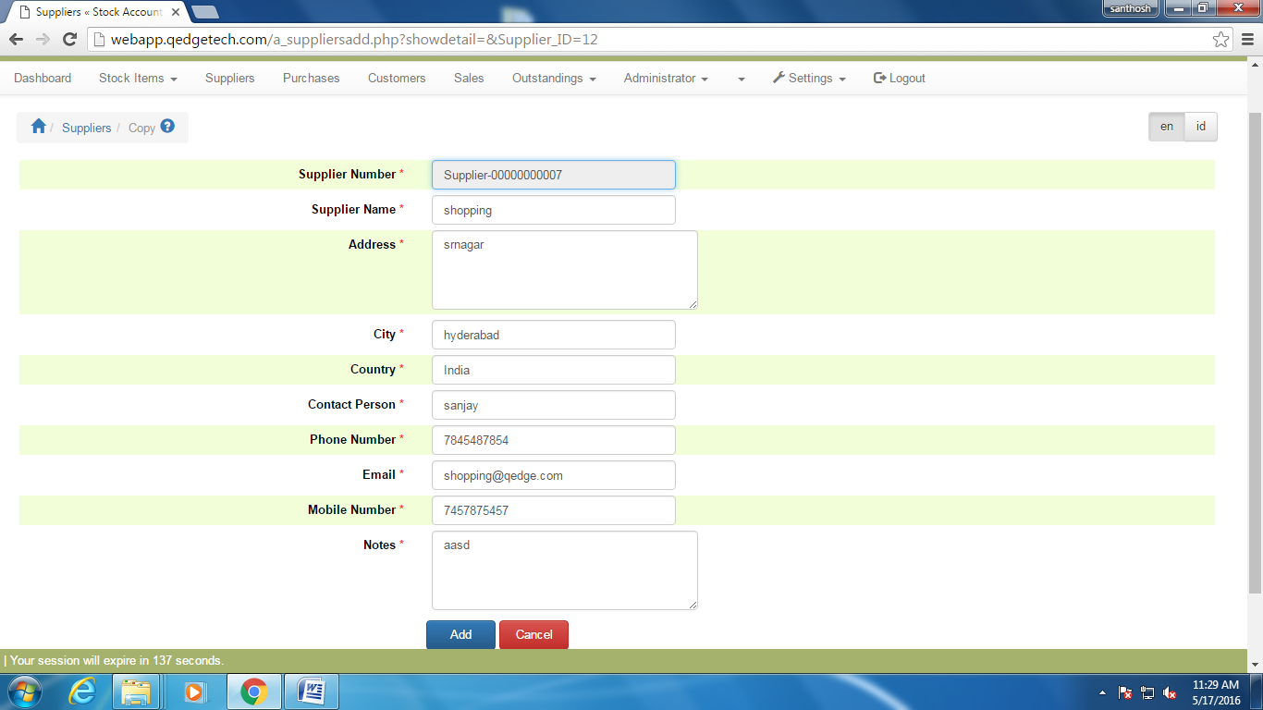

**4.4.3 Suppliers Copy UseCase Diagram :**

If valid

Click Copy

Enter Supplier Details

Click Add

Click Cancel

**4.5.0 Suppliers Deletion:**

**4.5.1 Overview:**

This feature is useful for Admin to delete an unwanted Suppliers

If Dependency

Select Supplier Record

Click Action & Click Delete

Click Ok

Click Cancel

yes

No

**5.0 Purchaser Details:**

**5.1 Overview:**

Purchaser Feature allows admin to define a new purchaser, modify or delete and any purchaser also admin can search for purchasers information based on the given selection criteria.

**5.1.2 Prototype**

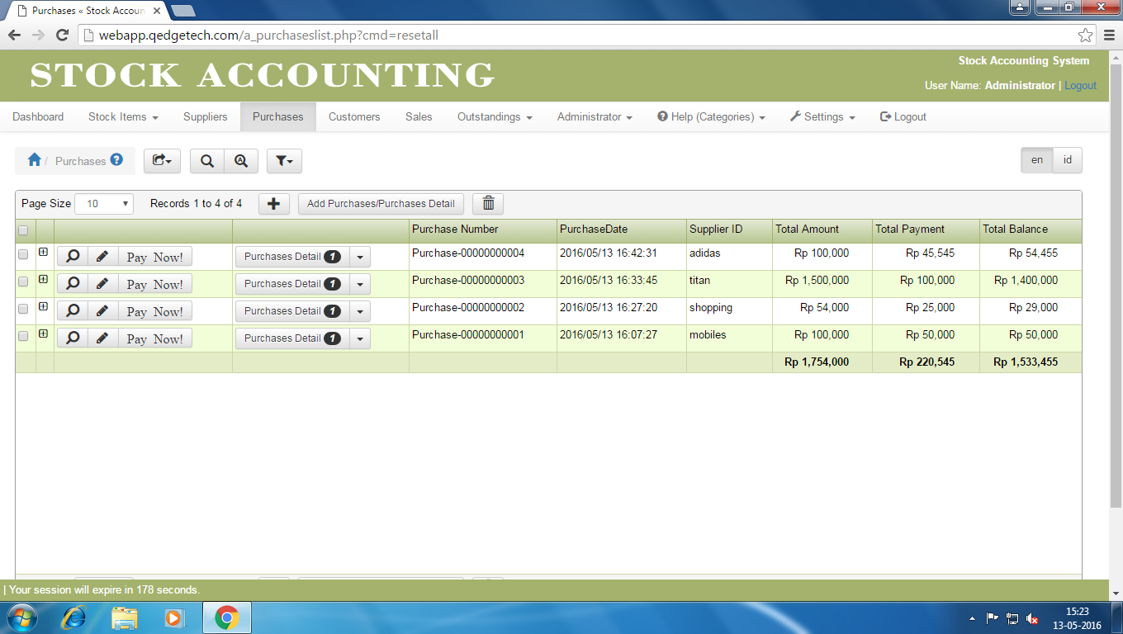

5.1.3 Page Elements :

Purchage Page

|  |  |  |  |
| --- | --- | --- | --- |
| Element Name | Element Type | User Action | System  Response |
| **Purchage** | |  |  |
| Export | Button | Click | As per task flow diagram |
| Search | Button | Click | As per task flow diagram |
| Advance Search | Link | Click | As per task flow diagram |
| Filter | Link | Click | As per task flow diagram |
| Purchage Table | | | |
| Check Box | Button | Click | As per task flow diagram |
| Span | Button | Click | As per task flow diagram |
| View | Button | Click | As per task flow diagram |
| Pay Now | Link | Click | As per task flow diagram |
| Edit | Button | Click | As per task flow diagram |
| Purchases Details | Link | Click | As per task flow diagram |
| Add | Button | Click | As per task flow diagram |
| Page Size | List Box | Slect | As per task flow diagram |
| Delete | Button | Click | As per task flow diagram |
| Add Pruchses /Purchase Details | Link | Click | As per task flow diagram |

**5.2 Purchaser Creation:**

**5.2.1 Overview:**

This feature allows Admin to create a new purchaser for Stock Accounting.

**5.2.2 Prototype**

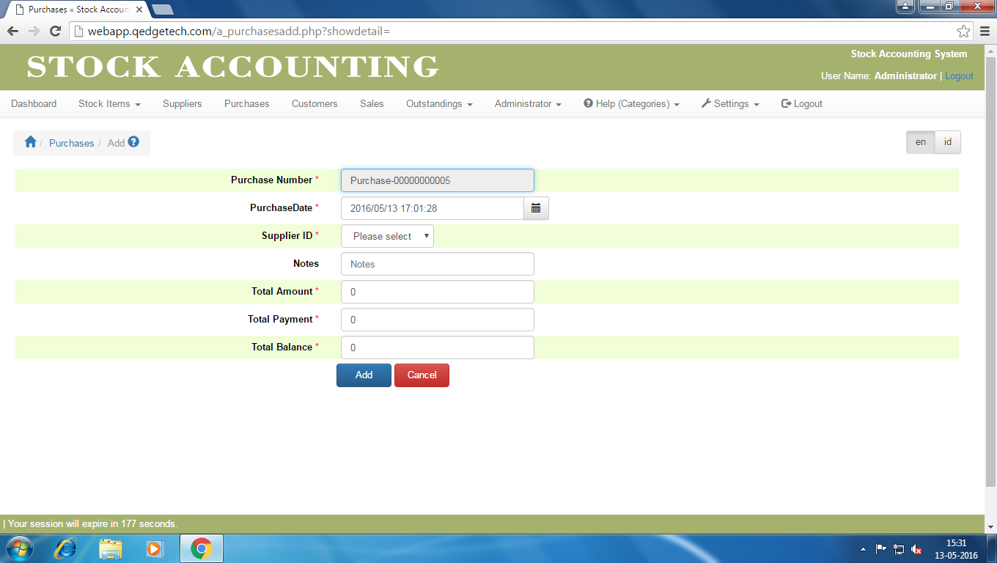

**5.2.3 Purchaser Creation Page Elements :**

Purchase Creation Page

|  |  |  |  |
| --- | --- | --- | --- |
| Element Name | Element Type | User Action | System  Response |
| **Purchase Creation** | |  |  |
| Purchase Number | Text Box | Auto fill | As per task flow diagram |
| Purchase Date | Text Box | Enter | As per task flow diagram |
| Supplier Id | List Box | Select | As per task flow diagram |
| Notes | Text Box | Enter | As per task flow diagram |
| Total Amount | Text Box | Enter | As per task flow diagram |
| Total Payment | Text Box | Enter | As per task flow diagram |
| Total Balance | Text Box | Enter | As per task flow diagram |
| Add | Button | Click | As per task flow diagram |
| Cancel | Button | Click | As per task flow diagram |

**5.2.4 Purchaser Creation UseCase Diagram:**

If valid

Click Add

Enter Purchase Details

Click Add

Click Cancel

No

Yes

**5.3.0 Purchaser Updation :**

**5.3.1 Overview:**

This feature allows Admin to modify the details of Purchasers.

**5.3.2 Prototype**

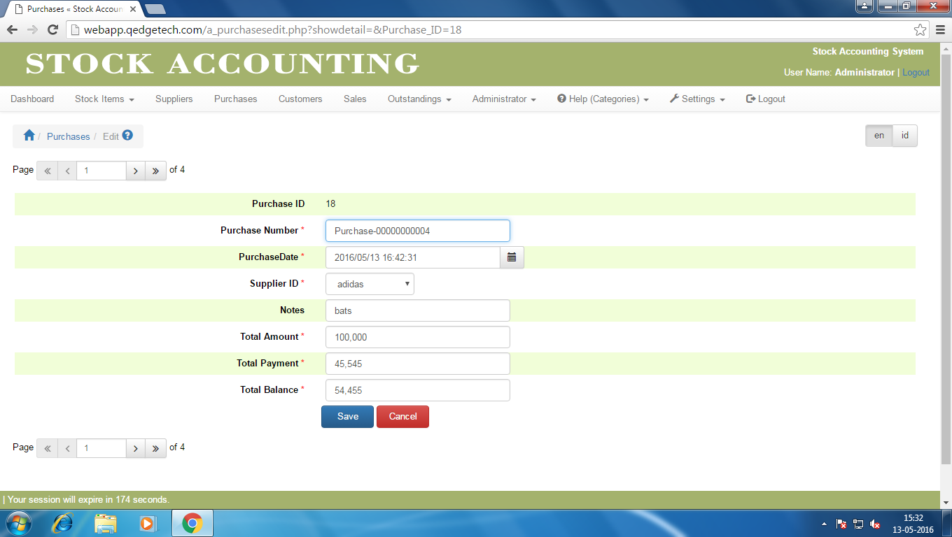

**5.3.3 Page Elements :**

Purchase Updation Page

|  |  |  |  |
| --- | --- | --- | --- |
| Element Name | Element Type | User Action | System  Response |
| **Purchase Updation** | |  |  |
| Purchase Number | Text Box | Auto fill | As per task flow diagram |
| Purchase Date | Text Box | Enter | As per task flow diagram |
| Supplier Id | List Box | Select | As per task flow diagram |
| Notes | Text Box | Enter | As per task flow diagram |
| Total Amount | Text Box | Enter | As per task flow diagram |
| Total Payment | Text Box | Enter | As per task flow diagram |
| Total Balance | Text Box | Enter | As per task flow diagram |
| Save | Button | Click | As per task flow diagram |
| Cancel | Button | Click | As per task flow diagram |

**5.3.4 Purchaser Updation UseCase Diagram:**

If valid

Click Edit

Enter Purchase Details

Click Save

Click Cancel

No

Yes

**5.4 Purchaser Deletion UseCase Diagram :**

**5.4.1 Overview:**

This feature is useful for Admin to delete an unwanted Suppliers

If Dependency

Select Record

Click Delete

Click Ok

Click Cancel

yes

No

**6.0 Customer Details :**

**6.1 Overview:**

Customer Feature allows admin to define a new customer, modify or delete and any customer also admin can search for customers information based on the given selection criteria.

**6.1.2 Prototype**

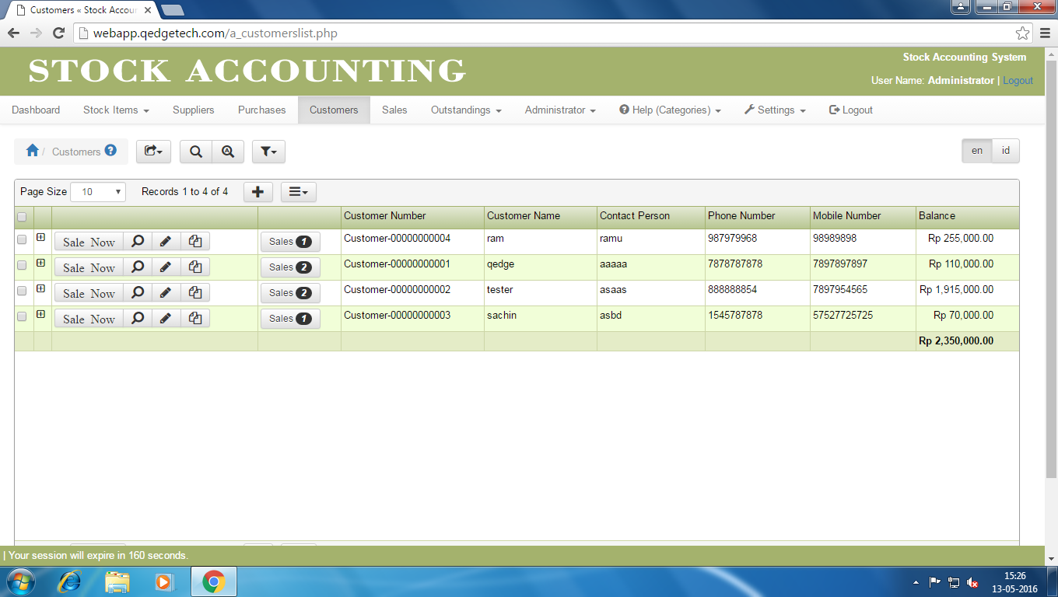

**6.1.3 Page Elements :**

Customers Page

|  |  |  |  |
| --- | --- | --- | --- |
| Element Name | Element Type | User Action | System  Response |
| **Customers** | |  |  |
| Export | Button | Click | As per task flow diagram |
| Search | Button | Click | As per task flow diagram |
| Advance Search | Link | Click | As per task flow diagram |
| Filter | Link | Click | As per task flow diagram |
| Customers Table | | | |
| Check Box | Button | Click | As per task flow diagram |
| Span | Button | Click | As per task flow diagram |
| Sale Now | Link | Click | As per task flow diagram |
| View | Button | Click | As per task flow diagram |
| Edit | Button | Click | As per task flow diagram |
| Copy | Button | Click | As per task flow diagram |
| Sales | Link | Click | As per task flow diagram |
| Page Size | List Box | Select | As per task flow diagram |
| Add | Button | Click | As per task flow diagram |
| Actions | Button | Click | As per task flow diagram |

**6.2.0 Customer Creation:**

**6.2.1 Overview:**

This feature allows Admin to create a new Customer for Stock Accounting.

**6.2.2 Prototype**

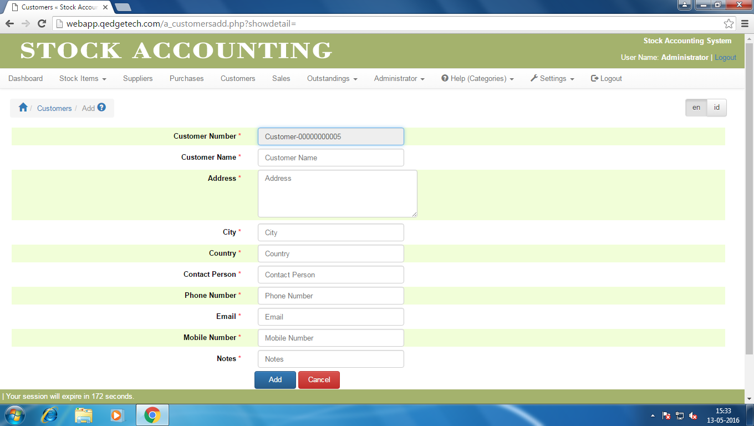

**6.2.3 Page Elements :**Customer Creation Page

|  |  |  |  |
| --- | --- | --- | --- |
| Element Name | Element Type | User Action | System  Response |
| **Customer Creation** | |  |  |
| Customer Number | Text Box | Auto fill | As per task flow diagram |
| Customer Name | Text Box | Enter | As per task flow diagram |
| Address | Text Box | Enter | As per task flow diagram |
| City | Text Box | Enter | As per task flow diagram |
| Country | Text Box | Enter | As per task flow diagram |
| Contact Person | Text Box | Enter | As per task flow diagram |
| Phone Number | Text Box | Enter | As per task flow diagram |
| Email | Text Box | Enter | As per task flow diagram |
| Mobile Number | Text Box | Enter | As per task flow diagram |
| Notes | Text Box | Enter | As per task flow diagram |
| Add | Button | Click | As per task flow diagram |
| Cancel | Button | Click | As per task flow diagram |

**6.2.4 Customer Creation UseCase Diagram :**

If valid

Click Add

EnterCustomers Details

Click Add

Click Cancel

**6.3.0 Customer Updation:**

**6.3.1 Overview:**

This feature allows Admin to modify the details of Customers.

**6.3.2 Prototype**

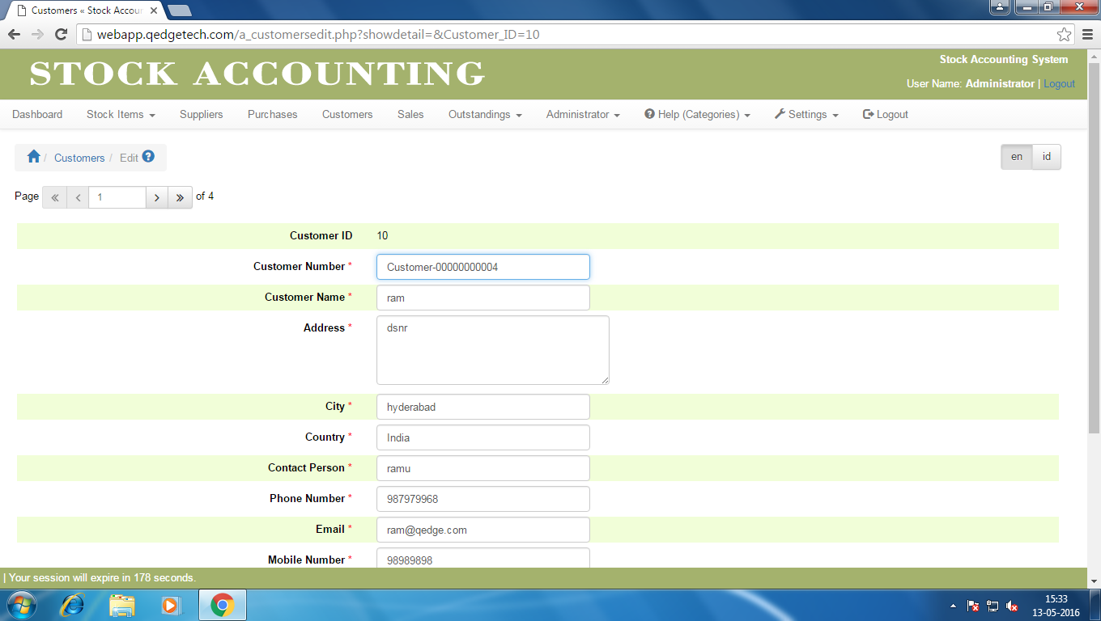

**6.3.3 Page Elements :**

Customer Updation Page

|  |  |  |  |
| --- | --- | --- | --- |
| Element Name | Element Type | User Action | System  Response |
| **Customer Updation** | |  |  |
| Customer Number | Text Box | Auto fill | As per task flow diagram |
| Customer Name | Text Box | Enter | As per task flow diagram |
| Address | Text Box | Enter | As per task flow diagram |
| City | Text Box | Enter | As per task flow diagram |
| Country | Text Box | Enter | As per task flow diagram |
| Contact Person | Text Box | Enter | As per task flow diagram |
| Phone Number | Text Box | Enter | As per task flow diagram |
| Email | Text Box | Enter | As per task flow diagram |
| Mobile Number | Text Box | Enter | As per task flow diagram |
| Notes | Text Box | Enter | As per task flow diagram |
| Balance | Text Box | Enter | As per task flow diagram |
| Save | Button | Click | As per task flow diagram |
| Cancel | Button | Click | As per task flow diagram |
| Page | Text Box | Enter | As per task flow diagram |

**6.3.4 Customer Updation UseCase Diagram:**

If valid

Click Edit

EnterCustomers Details

Click Save

Click Cancel

**6.4.0 Customer Deletion Usecase Diagram :**

6.4.1 Overview:

This feature is useful for Admin to delete an unwanted Customers

If Dependency

Select Record

Click Actions & Click Delete

Click Ok

Click Cancel

yes

No

**7.0 Sales Details:**

**7.1 Overview:**

Sales Feature allows admin to define a new sale, modify or delete and any sales also admin can search for sales information based on the given selection criteria.

**7.1.2 Prototype**

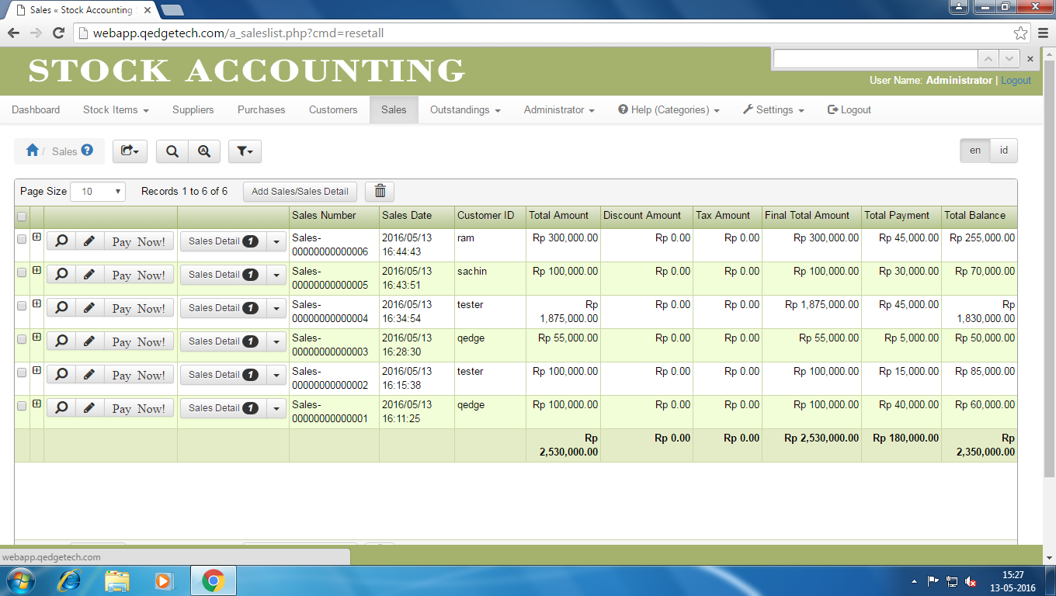

**7.1.3 Page Elements :**

Sales Page

|  |  |  |  |
| --- | --- | --- | --- |
| Element Name | Element Type | User Action | System  Response |
| **Sales** | |  |  |
| Export | Button | Click | As per task flow diagram |
| Search | Button | Click | As per task flow diagram |
| Advance Search | Link | Click | As per task flow diagram |
| Filters | Link | Click | As per task flow diagram |
| Sales Table | | | |
| Check Box | Button | Click | As per task flow diagram |
| Span | Button | Click | As per task flow diagram |
| View | Button | Click | As per task flow diagram |
| Pay Now | Link | Click | As per task flow diagram |
| Edit | Button | Click | As per task flow diagram |
| Sales Details | Link | Click | As per task flow diagram |
| Add Sales/Sales Details | Link | Click | As per task flow diagram |
| Page Size | List Box | Slect |  |
| Delete | Button | Click |  |

**7.2 Sales Creation :**

**7.2.1 Overview:**

This feature allows Admin to create a new sale for Stock Accounting.

**7.2.2 Prototype**

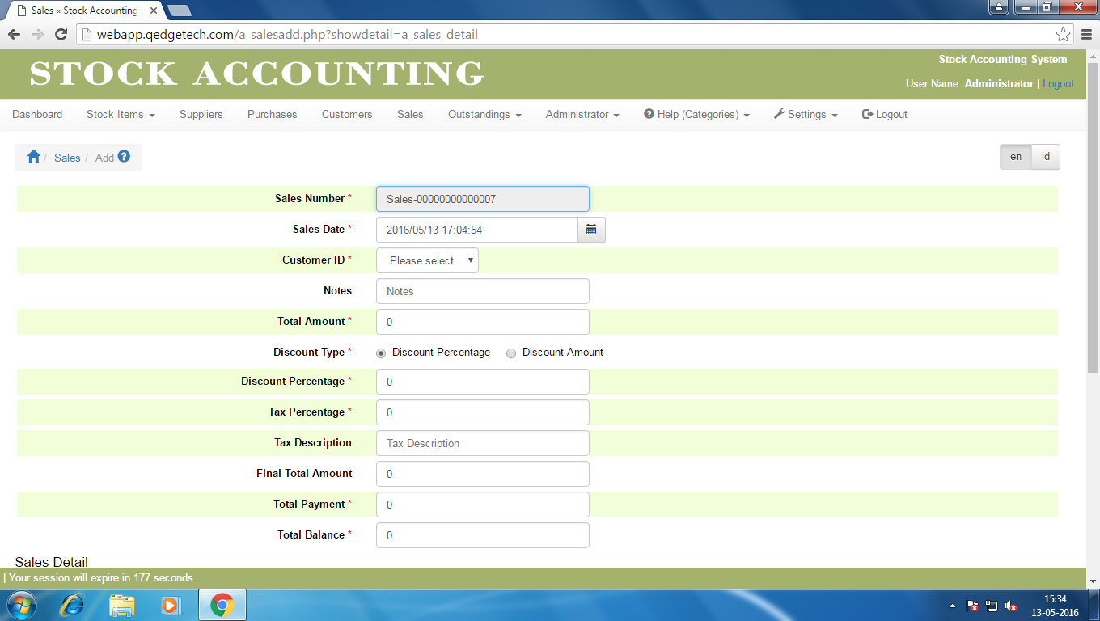

**7.2.3 Page Elements :**

Sales Creation Page

|  |  |  |  |
| --- | --- | --- | --- |
| Element Name | Element Type | User Action | System  Response |
| **Sales Creation** | |  |  |
| Sales Number | Text Box | Auto Fill | As per task flow diagram |
| Sales Date | Text Box | Enter | As per task flow diagram |
| Customer Id | List Box | Select | As per task flow diagram |
| Notes | Text Box | Enter | As per task flow diagram |
| Total Amount | Text Box | Enter | As per task flow diagram |
| Discount Type | Radio Button | Select | As per task flow diagram |
| Discount(Percentage/Amount) | Text Box | Enter | As per task flow diagram |
| Tax Percentage | Text Box | Enter | As per task flow diagram |
| Tax Description | Text Box | Enter | As per task flow diagram |
| Final Total Amount | Text Box | Auto Fill | As per task flow diagram |
| Total Payment | Button | Enter | As per task flow diagram |
| Total Balance | Button | Auto Fill | As per task flow diagram |
| Sales Details Table | | | |
| Supplier Number | List Box | Select | As per task flow diagram |
| Stock Item | List Box | Select | As per task flow diagram |
| Sales Quantity | Text Box | Enter | As per task flow diagram |
| Purchasing Price | Text Box | Enter | As per task flow diagram |
| Sales Price | Text Box | Enter | As per task flow diagram |
| Total Amount | Text Box | Auto Fill | As per task flow diagram |
| Add | Button | Click | As per task flow diagram |
| Cancel | Button | Click | As per task flow diagram |
| Delete | Button | Click | As per task flow diagram |
| Add Blank Row | Button | Click | As per task flow diagram |

**7.2.4 Sales Creation UseCase Diagram :**

If valid

Click Add Sales

Enter Sales Details

Click Add

Click Cancel

**7.3.0 Sales Updation :**

**7.3.1 Overview:**

This feature allows Admin to modify the details of sales.

**7.3.2 Prototype**

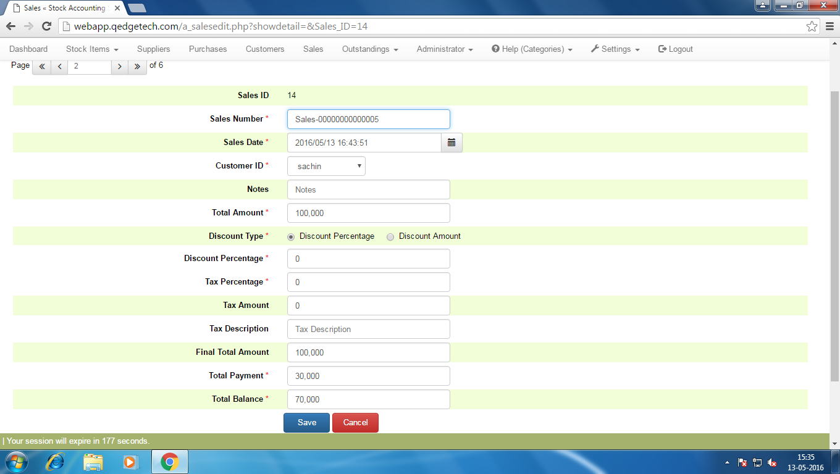

**7.3.3 Page Elements :**

Sales Updation Page

|  |  |  |  |
| --- | --- | --- | --- |
| Element Name | Element Type | User Action | System  Response |
| **Sales Updation** | |  |  |
| Sales Number | Text Box | Auto Fill | As per task flow diagram |
| Sales Date | Text Box | Enter | As per task flow diagram |
| Customer Id | List Box | Select | As per task flow diagram |
| Notes | Text Box | Enter | As per task flow diagram |
| Total Amount | Text Box | Enter | As per task flow diagram |
| Discount Type | Radio Button | Select | As per task flow diagram |
| Discount(Percentage/Amount) | Text Box | Enter | As per task flow diagram |
| Tax Percentage | Text Box | Enter | As per task flow diagram |
| Tax Amount | Text Box | Enter | As per task flow diagram |
| Tax Description | Text Box | Enter | As per task flow diagram |
| Final Total Amount | Text Box | Auto Fill | As per task flow diagram |
| Total Payment | Button | Enter | As per task flow diagram |
| Total Balance | Button | Auto Fill | As per task flow diagram |
| Save | Button | Click | As per task flow diagram |
| Cancel | Button | Click | As per task flow diagram |

**7.3.4 Sales Updation :**

If valid

Click Edit

Enter Sales Details

Click Save

Click Cancel

**7.4.0 Sales Deletion UseCase Diagram :**

**7.4.1 Overview:**

This feature is useful for Admin to delete an unwanted Sales

If Dependency

Select Record

Click Delete

Click Ok

Click Cancel

yes

No